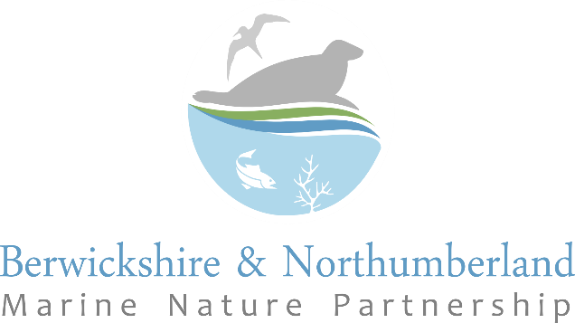

Student Bursary Scheme: Application Form

Deadline: 21st June 2024

Please submit the completed application form to: nick.brodin@northumberland.gov.uk

Student Contact Details:

Student Name
Address

Contact Number
University Attended
Course/Research Title

Project Title

Student’s Email Address
Supervisor’s Name
Supervisor’s Email

Summary:
Please summarise your project in approx. 100 words.

Rationale
Please explain why you have chosen to undertake this research (max 200 words)

Aim and Objectives
Please state the overall aim and objectives of the project (max 200 words).

Methodology and Timescale

Please state how you intend to undertake the research and the project timescale. Indicate any aspects of the methodology for which you may require external assistance (max 300 words).

Start Date: Estimated Completion Date:

Anticipated Outcome of the Research
Please describe what tangible benefits to the Berwickshire and Northumberland Marine Nature Partnership will result from your research (max 200 words).

Estimated Costs and Amount Applied For (maximum £300)
Please estimate the project costs. Please note that costs should be for core project work and associated expenses, not for printing and binding or hardware/software purchases or similar.

Are you applying for other grants/funding for this project?

Would the project go ahead in its proposed format if a bursary from the Berwickshire and Northumberland Marine Nature Partnership were not available?

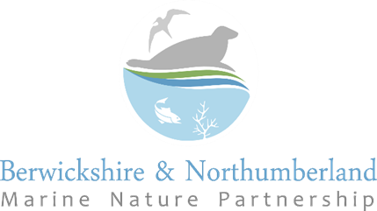

Summary of Key Partnership Research Interests

We are particularly interested in research which contributes towards any of the following topics:

Habitats, species and ecosystems
- Improved understanding of the distribution and condition of coastal and/or marine habitats in Berwickshire, Northumberland or North Tyneside
- Improved understanding of the distribution and population of coastal and/or marine species in Berwickshire, Northumberland or North Tyneside, particularly for species which are a designated feature of local marine protected areas or which are listed as being on Principle Conservation Importance in England or Scotland
- Investigations into potential opportunities or methods for protecting, enhancing or restoring coastal or marine habitats
- Investigations into potential opportunities methods for protecting and enhancing key coastal or marine species
- Research into water quality impacts on intertidal habitats and species
- Marine Invasive Non-Native Species, especially research which adds to our knowledge about their presence or distribution on our coast, contributes towards improved monitoring or surveillance, or which looks at improving biosecurity measures or management of invasives
- Improving the wildlife value of coastal infrastructure
- Improved mapping of the natural capital along our coast, including mapping and quantifying of ecosystem services.

Human Impacts on the Coast
- Greater understanding of the impacts of disturbance on coastal or marine wildlife and how these can be addressed. We are especially interested in research relevant to species which are part of the interest features of the suite of inshore marine protected areas along the Berwickshire, Northumberland and North Tyneside coast
- Changes in patterns or causes of public pressure on sites and on the interest features of marine protected areas, including research into new or emerging sources of disturbance

Fisheries and Hand-Gathering
- The impacts of hand-gathering and bait collection activities along our coast
- The link between impacts of hand gathering and site accessibility
- The extent and impact of crab tiling (especially where it involves the use of tyres)
- The environmental impacts of the use of bait to support potting activities
- Increased understanding of the causes and impacts of blue mussel declines

Climate Change
- Investigations into the likely impacts of climate change on habitats, species and ecosystems
- The potential contribution that restoration or creation of coastal and marine habitats could make to local Net Zero goals and/or to future climate change adaptation

Public Understanding of the coast
- Greater understanding of the effectiveness of coastal Codes of Conduct and their impact on behaviours
- Methods and approaches to achieve more effective outreach and communication with coastal stakeholders and the public
- Public understanding of the value of our coast and the benefits which it provides to local communities
- Levels of Ocean literacy amongst the public and how these can be increased locally
- Public perception of the impacts that their behaviour and choices have on local coastal and marine sites

